**ECE 375**

**LAB 1**

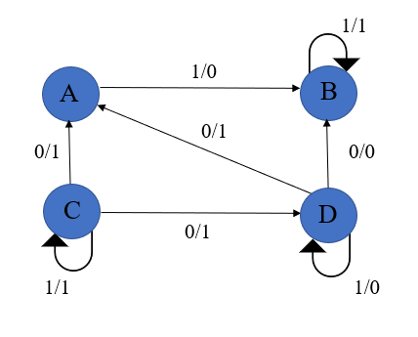1. Implement the following simple FSM using VHDL code and simulate it in ModelSim-Altera.